RESOLUTION NO.__________

RE: CERTIFICATE OF APPROPRIATENESS UNDER THE
PROVISIONS OF THE ACT OF THE PENNSYLVANIA
LEGISLATURE 1961, JUNE 13, P.L. 282 (53
SECTION 8004) AND BETHLEHEM ORDINANCE NO.
3952 AS AMENDED.

The applicant proposes to install a driveway, 5 parking spaces, a privacy fence
and landscaping at 105 E. Market St.

NOW, THEREFORE, BE IT RESOLVED by the Council of the City of Bethlehem that a Certificate of Appropriateness is hereby granted for the proposal.

Sponsored by: (s)

(s)

ADOPTED BY COUNCIL THIS DAY OF

(s)
President of Council

ATTEST:

(s)
City Clerk

HISTORICAL & ARCHITECTURAL REVIEW BOARD

The applicant proposes to install a driveway, 5 parking spaces, a privacy fence and landscaping at 105 E. Market St.

APPLICATION #6:

Jeff Youst
105 E. Market St.
Bethlehem, PA 18018

OWNER:

__________________________________________________________________________

The Board upon motion by Marsha Fritz and seconded by Gen Marcon adopted the proposal that City Council issue a Certificate of Appropriateness for the following:

- Paver drive wall to a bituminous parking are for 5 cars.

2. Using “Cobblestone” pavers with integral spacers for drainage.

3. The wooden fence will be 4’ high with masonry piers to match the cobblestone
pavers.

4. The fence by the first parking space to be stained with solid color similar to
stucco of the building. Fencing along east property to be stained a compatible
color to the brick.

5. The eastern fence color to be coordinated with the Historic Officer.

6. Cobblestone pavers and piers are to be a “Terra-cotta” color.

7. The masonry piers to have a dusk to dawn light fixture on each.

8. The motion was unanimously approved for the site work.

__________________________________________________________________________

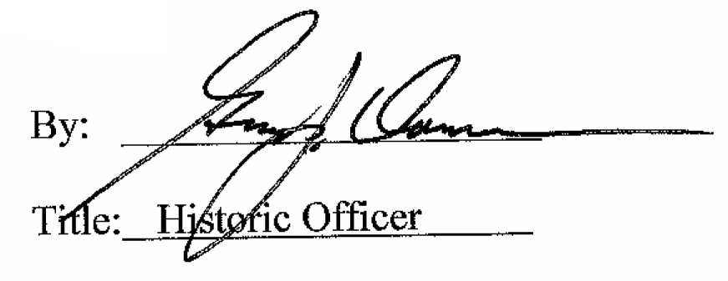

Date of Meeting: May 2, 2018

